A201-Afr-Egy-Osiris-Ostrich Feathers, Crook and Flagellum-Hieroglyphs-Ptolemaic Dynasty-305-30 BCE

**-Blue Faience**

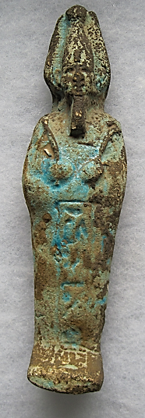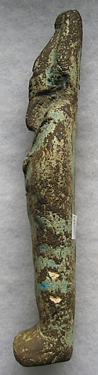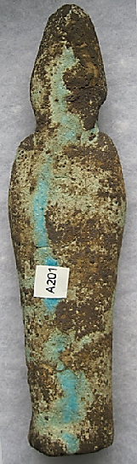

**Case No.: 2**

**Formal Label:** Osiris-Ostrich Feathers, Crook and Flagellum-Hieroglyphs-Late Period-525-334 BCE**-Blue Faience**

**Display Description: This amulet depicts** Osiris as a blue-faience mummy. He wears an *atef* (*3tf)*,the crown of Upper Egypt with two ostrich feathers on either side. In his hands he holds the shepherd's crook (awet), and the flagellum ( *nekhakha*).

**Accession Number: A201.**

**LC Classification:** DT62.

**Date or Time Horizon:** 305-30 BCE

**Geographical Area: Old Cairo, Egypt**

**Map, GPS Coordinates:** 30.12933 31.30753; 40° 26' 46" N 79° 58' 56" W

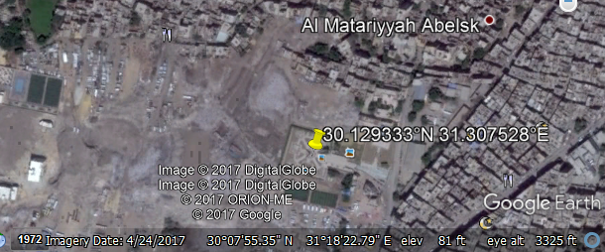

**Cultural Affiliation:** Ptolemaic Dynasty

**Medium:** Blue faience

**Dimensions: 165.79 mm; 6.53 in.  
Weight: 116 gm; 4 oz.**

**Provenance: unknown.**

**Condition: original.**

**Discussion:** Originally, ca. 2613- 2494 BCE in the 4th Dynasty, Anedjti (Egyptian anD.tj), the shepherd god of the 9th nome of Lower Egypt wore a simple crown with two ostrich feathers (Bunson 1991: 37, Allen 2005: Pyramid Texts spell 220). The ostrich feather on his crown signified a pure heart in shepherding his goats, since the ostrich feather was the symbol of the goddess of truth, Ma'at: to be worthy to enter eternal afterlife one’s spiritual heart had to be weighed and found to be lighter than an ostrich feather. Then, ca. 2400–2300 BCE, the shepherd's crook (awet) evolved into a symbol of a ruler’s governing strategy. About the same time, the flagellum ( *nekhakha*), a whip with three potent lashes that had been used to guide livestock, evolved into a symbol of the ruler's coercive power (see Wilkinson 1999: 190). These three elements emerging from animal husbandry, the feather, the crook and the flagellum were conjoined by 2300 BCE into a new image of human salvation; Osiris became the governing power of eternal afterlife.

**References:**

Allen, James P., trans. 2005. *The ancient Egyptian pyramid texts*. Atlanta: Society of Biblical Literature.

Bunson, Margaret R. 1991. *Encyclopedia of Ancient Egypt*. New York: Facts on File Inc.

Griffiths, John Gwyn. 1980. *The origins of Osiris and his cult* (Studies in the history of religions). Leiden: Brill.

Wilkinson, Richard H. 2003. The Complete Gods and Goddesses of Ancient Egypt. London: Thames and Hudson.

Wilkinson, Toby A.H. 1999. Early Dynastic Egypt. London: Routledge.